VISVESVARAYA TECHNOLOGICAL UNIVERSITY
JNANA SANGAMA, BELAGAVI – 590 018, KARNATAKA, INDIA
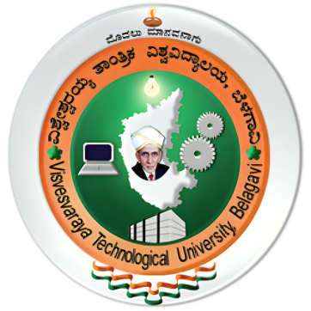

INTERNSHIP REPORT
ON
Data Science & AI/ML MakeX

Submitted in partial fulfillment of the requirements for the award of

MASTER OF COMPUTER APPLICATIONS (MCA)

Submitted By

Name USN
Ruchitha K M 4VP24MC041

Under the Guidance of
Prof. Neema H
Assistant Professor
Department of Master of Computer Applications
Vivekananda College of Engineering & Technology

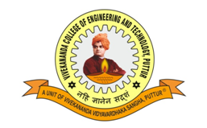
DEPARTMENT OF MASTER OF COMPUTER APPLICATIONS
VIVEKANANDA COLLEGE OF ENGINEERING & TECHNOLOGY
[A Unit of Vivekananda Vidyavardhaka Sangha, Puttur (R)]
Affiliated to Visvesvaraya Technological University and Approved by AICTE New Delhi & Govt. of Karnataka
Nehru Nagara, Puttur – 574 203, DK, Karnataka, India
May 2026

